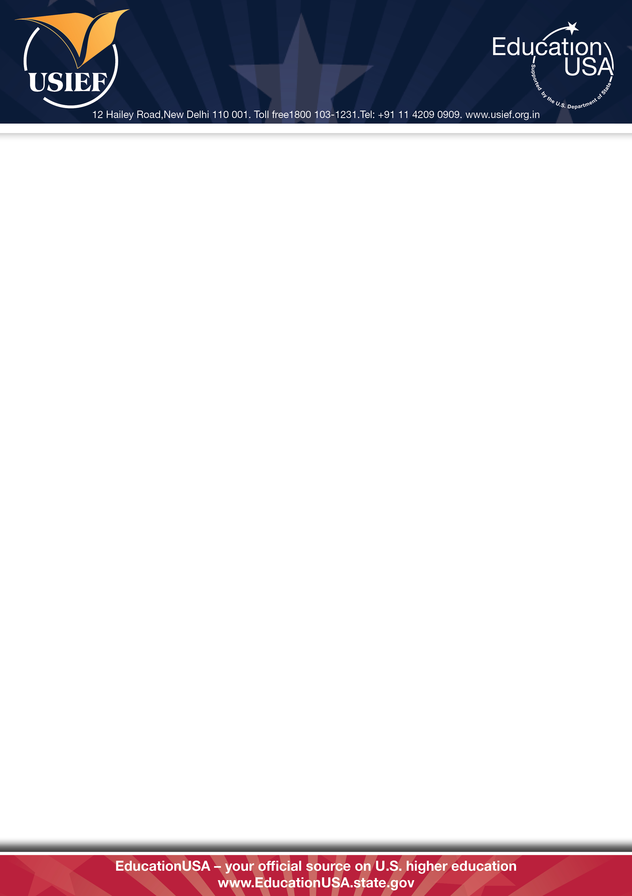

USIEF on Saturdays

We are delighted to announce that from February 2012 our EducationUSA offices in Delhi and Mumbai will remain open on all Saturdays while the office in Kolkata will now work on Second and Fourth Saturdays as well.

The office timings are between 9 am and 5 pm.

We hope these new working hours will help many working professionals, students and parents to avail our services on US higher education.

These services will now also be available on Saturdays:

• Free Basic Orientation Session on US higher education (3pm in Delhi and 11 am in Mumbai)

• Application submission for the USIEF library membership

• Submission of documents for attestation

• Library use for the test preparation resources and internet services (only members)

• Meeting with Educational Adviser (only members with appointment)

